**PRACTICAL NO: 1**

**AIM: DESIGN A DATABASE AND CREATE REQUIRED TABLES WITH CONSTRAINTS**

CREATE DATABASE FYIT_40

USE FYIT_40

CREATE TABLE CUSTOMER

(custno varchar(10) primary key,

cname varchar(20) not null,

cadd varchar(30),

city varchar(20),

pincode integer,

state varchar(20),

creditlimit integer)

select * from CUSTOMER

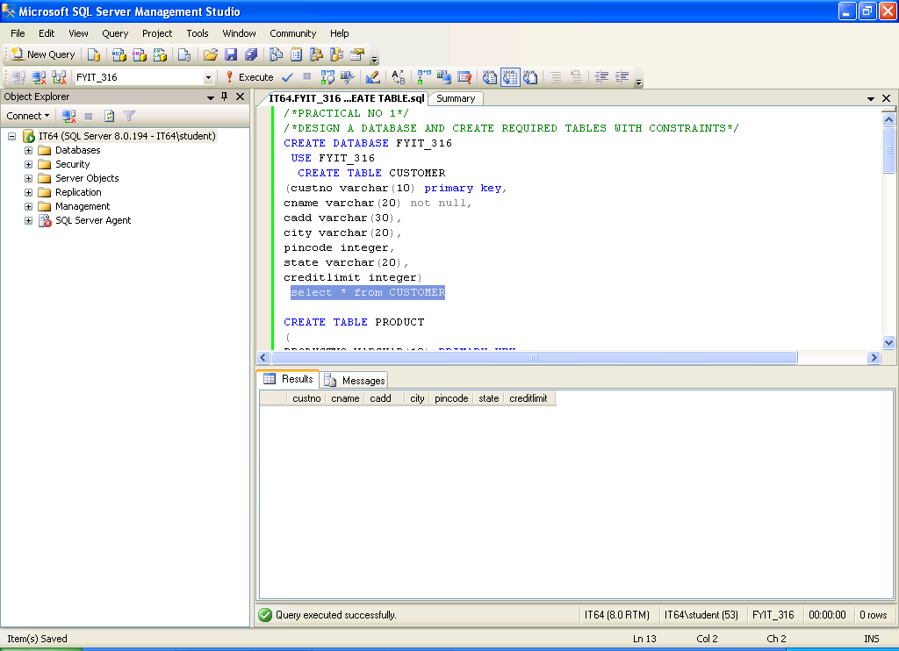

CREATE TABLE PRODUCT

(PRODUCTNO VARCHAR(10) PRIMARY KEY,

DESCRIPTION VARCHAR(10) NOT NULL,

UNITMEASURE INTEGER,

QTYONHAND INTEGER,

SELLPRICE INTEGER,

COSTPRICE INTEGER)

SELECT * FROM PRODUCT

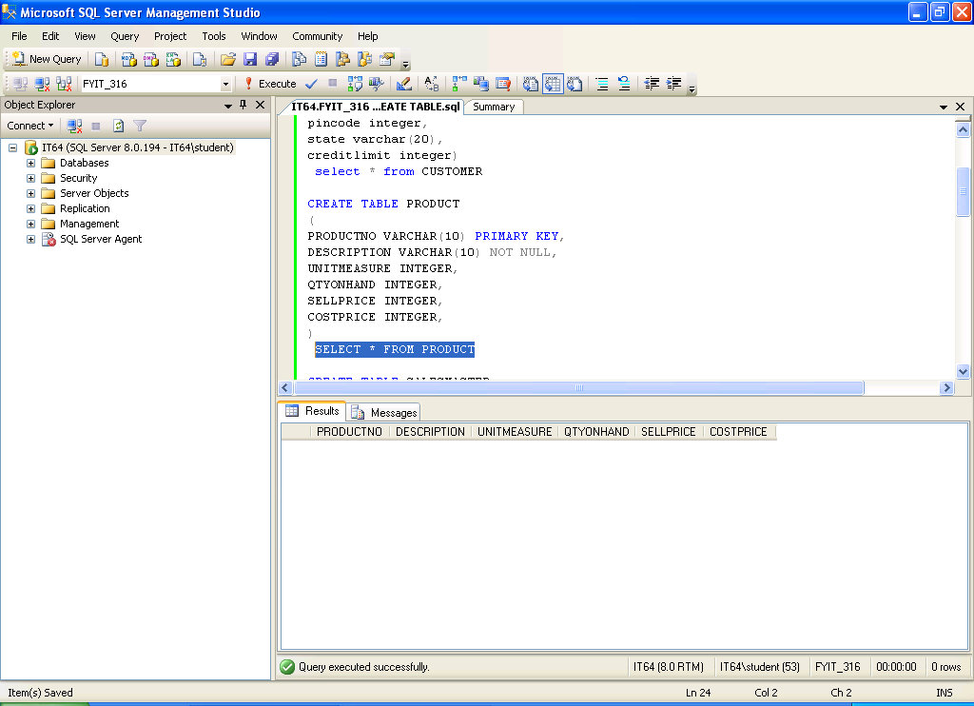

CREATE TABLE SALESMASTER

(SALESMANNO VARCHAR(10) PRIMARY KEY,

SNAME VARCHAR(20) NOT NULL,

ADDRESS VARCHAR(30),

CITY VARCHAR(20),

PINCODE INTEGER,

STATE VARCHAR(20),

SALESAMT NUMERIC(8,2),

TARGET NUMERIC(8,2))

SELECT * FROM SALESMASTER

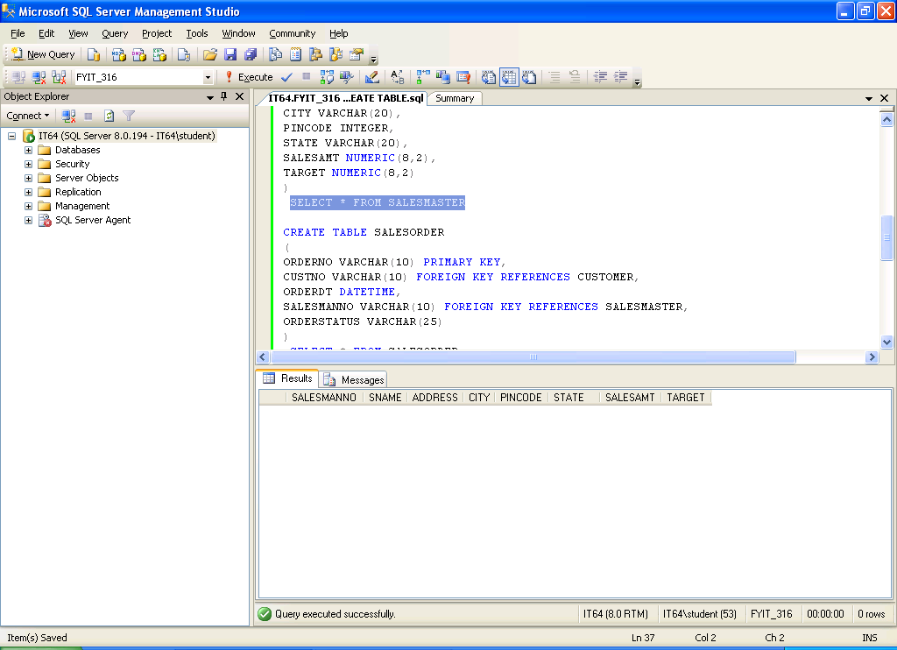

CREATE TABLE SALESORDER

(ORDERNO VARCHAR(10) PRIMARY KEY,

CUSTNO VARCHAR(10) FOREIGN KEY REFERENCES CUSTOMER,

ORDERDT DATETIME,

SALESMANNO VARCHAR(10) FOREIGN KEY REFERENCES SALESMASTER,

ORDERSTATUS VARCHAR(25))

SELECT * FROM SALESORDER

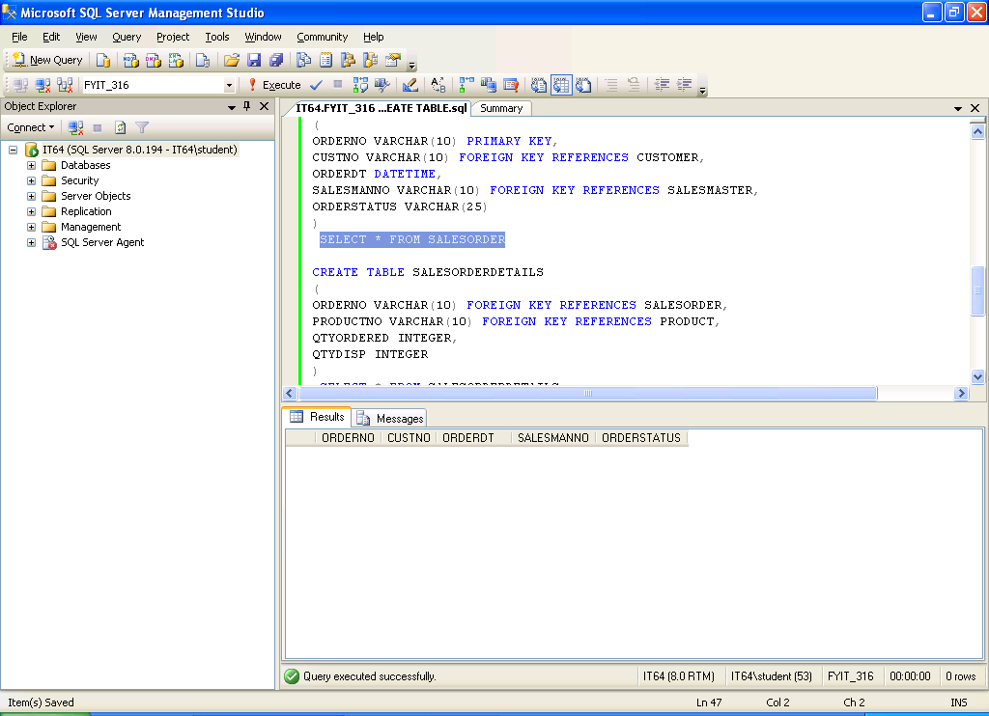

CREATE TABLE SALESORDERDETAILS

(ORDERNO VARCHAR(10) FOREIGN KEY REFERENCES SALESORDER,

PRODUCTNO VARCHAR(10) FOREIGN KEY REFERENCES PRODUCT,

QTYORDERED INTEGER,

QTYDISP INTEGER)

SELECT * FROM SALESORDERDETAILS

